Name:__________________________________Date ______________Period:_____
The 13 Colonies Map
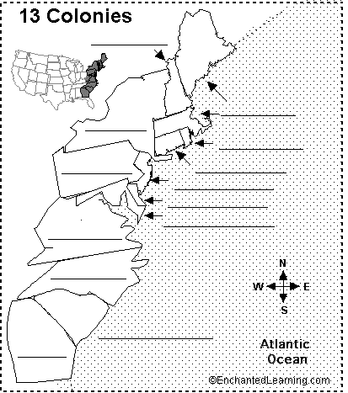
- Neatly label each state using full name and correct spelling
- Using 3 different colors, neatly outline the three different regions and label the regions “New England,” “Middle” and “Southern”.
- On the back, write a Compare and contrast statement which includes commentary on the social, economic, geographic differences of each region.

