2016 Presidential Candidates

Pick 2 Front-Runners and 1 Long-shots and answer the following questions on a separate sheet of paper.

- Name of Candidate and their political party.
- Where are they from?
- What experience do they have? (Give a very short resume of important jobs they’ve had and/or government experience some might not have any government experience!)
- What groups are supporting him/her? (Conservatives, Liberals Tea Party, Gun-Rights Activists, Banks, Unions, Evangelicals, College Students, Businesses etc)
- How much support does this candidate have according to two national polls (you pick the polls; look at the news for this info or just Google it!)
- How much money have they raised? (Google it or look at opensecrets.org)
- What are the three most important issues/problems this candidate wants to address if they become president? What does their campaign focus on?
- Watch any video their campaign has produced (commercial, public statement, etc). Describe their speaking ability. (E.g. do they seem like a good speaker? Why/why not? Do they give the impression that they would be a strong leader? Why/why not?)
- Can he/she win? Why/why not? (Yes, this is YOUR opinion)

Frontrunnners | 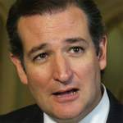 |  | 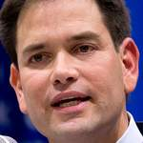 |  | 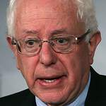
 | Cruz - R | Clinton - D | Rubio - R | Trump - R | Sanders - D
The Longshots | 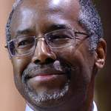 |  | 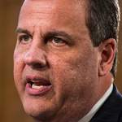 | 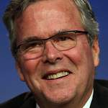 | 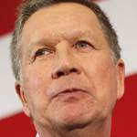
 | Carson - R | Fiorina - R | Christie - R | Bush - R | Kasich - R

