Name: _____________________ Period: ___

Cold War Document Based Question

**Please make sure you bring this packet to class! You will not receive another packet!

Prompt: Were the methods the US used to fight the Cold War justified?

Document A
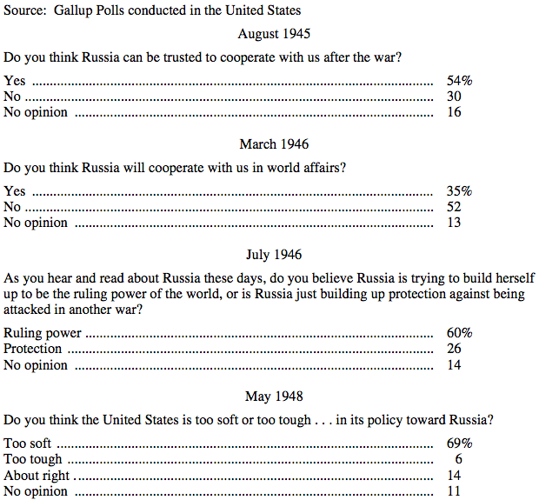

1. How did Americans’ view on Russia change?

2. Do you think this document shows that US actions during the Cold War were justified? Why?
Document B
Source: This is an excerpt from Secretary of State Marshall’s speech explaining his plan for European recovery, June 5, 1947

I need to say that the world situation is very serious. . . . Europe must have a great deal of additional help, or face heavy economic, social, and political damage. This would have a harmful effect on the world at large. There are also possibilities of disturbances because of the desperation of the people concerned. The effect on the economy of the United States should be clear to all. So the United States should do whatever it can to help restore normal economic health to the world. Without this there can be no political stability or peace. Our policy is directed . . . against hunger, poverty, desperation and chaos [disorder]. Its purpose is to revive a working economy in the world.

1. Why did Secretary of State Marshall suggest this plan for European recovery?

2. Do you think this document shows that US actions during the Cold War were justified? Why?

Document C
Source: Communist Control Act of 1954

The Congress hereby finds and declares that the Communist Party of the United States, although purportedly a political party, is in fact an instrumentality of a conspiracy to overthrow the Government of the United States. It constitutes an authoritarian dictatorship within a republic, demanding for itself the rights and privileges accorded to political parties, but denying to all others the liberties guaranteed by the Constitution. Unlike political parties, which evolve their policies and programs through public means, by the reconciliation of a wide variety of individual views, and submit those policies and programs to the electorate at large for approval or disapproval, the policies and programs of the Communist Party are secretly prescribed for it by the foreign leaders of the world Communist movement....Therefore the Communist Party should be outlawed.

1. Why do you think Congress wanted to make a law to control the Communist Party in America?

2. Do you think this document shows that US actions during the Cold War were justified? Why?

Document D
Source: President Harry Truman, Press Release, June 27, 1950

. . . The attack upon Korea makes it plain beyond all doubt that Communism has passed beyond the use of subversion to conquer independent nations and will now use armed invasion and war. It has defied the orders of the Security Council of the United Nations issued to preserve international peace and security. In these circumstances the occupation of Formosa [Taiwan] by Communist forces would be a direct threat to the security of the Pacific area and to United States forces performing their lawful and necessary functions in that area.

Accordingly I have ordered the Seventh Fleet to prevent any attack on Formosa. As a corollary of this action I am calling upon the Chinese Government on Formosa to cease all air and sea operations against the mainland. The Seventh Fleet will see that this is done. The determination of the future status of Formosa must await the restoration of security in the Pacific, a peace settlement with Japan, or consideration by the United Nations. . . .

1. What reasons does President Truman give for being involved in Korea?

2. Do you think this document shows that US actions during the Cold War were justified? Why?

Document E
Source: Annie Dillard, An American Childhood, Harper & Row

When the air-raid siren sounded, our teachers stopped talking and led us to the school basement. There the gym teachers lined us up against the cement walls and steel lockers, and showed us how to lean in and fold our arms over our heads. Our small school ran from kindergarten through twelfth grade. We had air-raid drills in small batches, four or five grades together, because there was no room for us all against the walls. The teachers had to stand in the middle of the basement rooms: those bright Pittsburgh women who taught Latin, science, and art, and those educated, beautifully mannered European women who taught French, history, and German, who had landed in Pittsburgh at the end of their respective flights from Hitler, and who had baffled us by their common insistence on tidiness, above all, in our written work.
The teachers stood in the middle of the room, not talking to each other. We tucked against the walls and lockers: dozens of clean girls wearing green jumpers, green knee socks, and pink-soled white bucks. We folded our skinny arms over our heads…

1. How did the Cold War affect Dillard’s childhood?

2. Do you think this document shows that US actions during the Cold War were justified? Why?
Document F
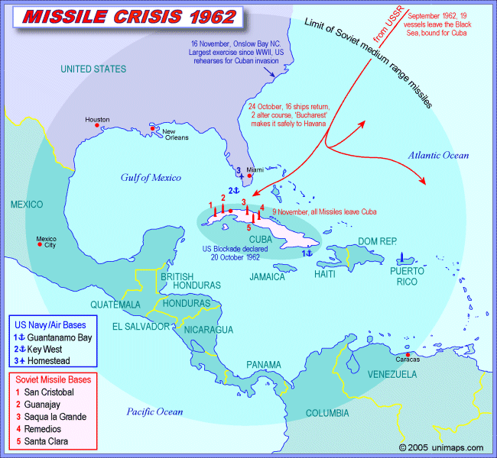
1. Why was the Cuban Missile Crisis so scary for Americans? How was the Cuban Missile Crisis resolved (dip back to your knowledge from class)?

2. Do you think this document shows that US actions during the Cold War were justified? Why?

Document G
Source: President Johnson defends the American role in Vietnam, 1965

Why are we in South Vietnam? We are there because we have a promise to keep. Since 1954 every American President has offered support to the people of South Vietnam....We have made a national pledge to help South Vietnam defend its independence. And I intend to keep our promise.... We are also there to strengthen world order. Around the globe, from Berlin to Thailand, are people whose well-being rests, in part, on the belief that they can count on us if they are attacked. To leave Vietnam to its fate would shake the confidence of all these people in the value of American commitment, the value of America's word. The result would be increased unrest and instability, and even wider war. We are also there because there are great stakes in the balance. Let no one think for a moment that retreat from Vietnam would bring an end to conflict. The battle would be renewed in one country and then another. The central lesson of our time is that the appetite of aggression is never satisfied.

1. List 3 reasons President Johnson gives for why the United States should fight in Vietnam.

2. Do you think this document shows that US actions during the Cold War were justified? Why?

Document H
Source: CIA Director John McCone, 1965

“I think what we are doing in starting on a track which involves [combat troops in Vietnam will mean] and ever-increasing commitment of US [soldiers] without … improving the chances of victory… In effect, we will find ourselves mired down in combat in the jungle in a military effort that we cannot win, and from which we will have extreme difficulty extricating ourselves.

1. In your own words, what does McCone think will happen if the US sends in combat troops to Vietnam?

2. Do you think this document shows that US actions during the Cold War were justified? Why?

Document I
Source: Martin Luther King, 1967

. . . it became clear to me that the [Vietnam] war was doing far more than devastating the hopes of the poor at home. It was sending their sons and their brothers and their husbands to fight and die in extraordinarily high proportions relative to the rest of the population. We were taking the black young men who had been crippled by our society and sending them eight thousand miles away to guarantee liberties in Southeast Asia which they had not found in southwest Georgia and East Harlem.

1. Why is Martin Luther King against the Vietnam War?

2. Do you think this document shows that US actions during the Cold War were justified? Why?

Name: _____________________ Period: ___
ESSAY OUTLINE

Prompt: Were the methods the US used to fight the Cold War justified?

Introduction Paragraph
Background Information:

Thesis:

Main Idea  Evidence  Analysis  Link/Conclusion | Main Idea  Evidence  Analysis  Link/Conclusion
Main Idea  Evidence  Analysis  Link/Conclusion | Conclusion: Restate thesis/Evidence and explain topic’s importance on today’s society.

