**Name: Date: Period:**

**Atomic Bomb DBQ Essay**

**Essential Question: Did the U.S. make the correct decision to drop the atomic bomb on Japan?**

**Task: Analyze the documents related to the atomic bomb to understand the two sides of the debate.**

**Document 1: Scientists’ recommendations on the Immediate Use of Nuclear Weapons to the President of the United States**

June 16, 1945

You have asked us to comment on the use of the new weapon. We feel that using this weapon will make us the strongest country in the world. Also, we think using the atomic bomb will help save American lives in the Japanese war.

Some scientists do not agree with us. They think that using the atomic bomb in war will kill thousands of innocent people. They think that our government should demonstrate the use of the weapon to show other countries how powerful it is, but we should not use it on other humans. They fear that in the future our enemies could create an atomic bomb and use it against us so we should outlaw all atomic weapons. We do not agree with this view. We think the only way to end the war is to use the atomic bomb.

J. R. Oppenheimer

1. Explain three reasons why the scientists support the use of nuclear weapons.
2. Why do the scientists not agree with the views of the scientists who oppose nuclear weapons?
3. Right decision or wrong decision to use the bomb? Right Wrong

**Document 2: Letter Written from Undersecretary of Navy Ralph Bard to the Secretary of Navy, June 27, 1945, On Use of Atomic Bomb Against Japan**

I think that before the bomb is actually used against Japan that Japan should have some warning in advance. The United States respects human rights and believes in fair play so they should warn Japan of what will happen to them if they don’t surrender. I have also felt that the Japanese government may be trying to surrender.

RALPH A. BARD

27 June 1945

1. What does Bard think the U.S. should do before they drop the bomb?
2. What does Bard think that the Japanese government is trying to do?
3. Right decision or wrong decision to use the bomb? Right Wrong

**Document 3: Trinity Test, July 16, 1945, Eyewitness Accounts - Enrico Fermi (one of the scientists in charge of the atom bomb)**

On the morning of July 16th, I was stationed at a camp about ten miles from the site of the explosion. The explosion took place at about 5:30 A.M. I had my face protected by a large board of dark glass. My first impression of the explosion was the very intense flash of light, and a sensation of heat on the parts of my body that were exposed. I looked in the direction of the explosion through the dark glass and could see something that looked like flames rising and the countryside became much brighter. After a few seconds the rising flames lost their brightness and appeared as a huge mass of smoke with an expanded head like a gigantic mushroom that rose rapidly beyond the clouds probably to a height of 30,000 feet. After reaching its full height, the smoke stayed stationary for a while before the wind started moving it.

1. List three things that Fermi saw when he watched the explosion.
2. How did Fermi know that the bomb would be such a powerful weapon?
3. Right decision or wrong decision to use the bomb? Right Wrong

**Document 4: A PETITION TO THE PRESIDENT OF THE UNITED STATES** **by LEO SZILARD**

You have the power to decide whether or not to use atomic bombs against Japan.

We have been working in the field of atomic power for a number of years. Until recently we thought that one day the United States might be attacked by atomic weapons and the only way to defend ourselves would be with our own atomic weapons. Since this danger does not exist now we feel the need to say the following.

The war has to end quickly and destroying Japanese cities with atomic bombs may be very effective. However, we do not think the United States should use atomic bombs to destroy Japanese cities at this time. If the United States is going to use atomic bombs they should first warn Japan.

Atomic bombs are designed to ruthlessly destroy cities. Once they are used in war for the first time, it will be difficult for any country to resist the temptation of using them again. There is no limit to how deadly or destructive atomic bombs can become. Any nation that uses atomic bombs must take the responsibility for the devastation that may result.

Leo Szilard and 58 co-signers

1. According to Leo Szilard, why had the scientists been working to develop an atomic bomb?
2. What does Szilard want the U.S. to do before it drops the bomb on Japan?
3. According to Szilard, what would happen if the U.S. dropped the bomb?
4. Right decision or wrong decision to use the bomb? Right Wrong

**Document 5: Table of dead and injured from Hiroshima Atomic Bomb**

|  |  |  |  |  |
| --- | --- | --- | --- | --- |
| **Distance from  Ground Zero (miles)** | **Killed instantly** | | **Injured** | **Total deaths** |
| 0 -1.0 | | 86% | 10% | 31,200 |
| 1.0 - 2.5 | | 27% | 37% | 144,800 |
| 2.5 - 5.0 | | 2% | 25% | 80,300 |
| **Total** | | **27%** | **30%** | **256,300** |

1. What percentage of people within 1 mile of Ground Zero were killed instantly from the nuclear bomb?

1. In total, how many people died from the bomb in Hiroshima?
2. Right decision or wrong decision to use the bomb? Right Wrong

**Document 6: Photographs from Hiroshima, August 13, 1945**

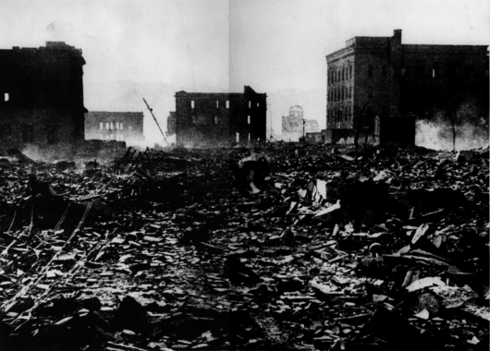

1. What caused the destruction seen in the pictures?
2. 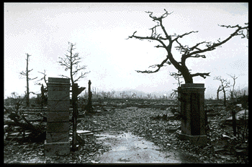What would have happened to the people living in these areas?
3. Right decision or wrong decision to use the bomb? Right Wrong

**Document 7: U.S. President Harry Truman’s reasons for using the bomb**

"Having found the bomb we have used it. We have used it against those who attacked us without warning at Pearl Harbor, against those who have starved and beaten and executed American prisoners of war, against those who have abandoned all pretense of obeying international laws of warfare. We have used it in order to shorten the agony of war, in order to save the lives of thousands and thousands of young Americans."

1. Explain three reasons why Truman believes he was correct to use the bomb.
2. Why does Truman mention Pearl Harbor?
3. Right decision or wrong decision to use the bomb? Right Wrong

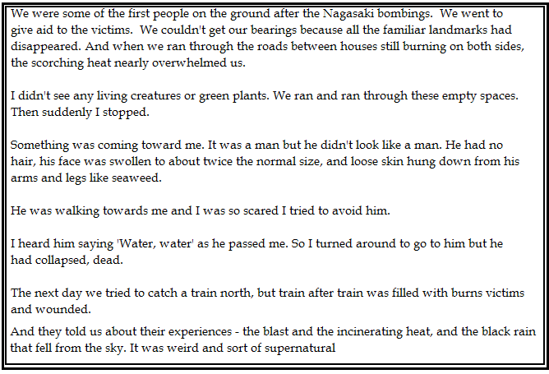**Document 8: Account of the attack on Nagasaki by Akeita Seitelbach, a first-aid nurse**

1. Based on this document, list TWO effects that the nuclear bomb had on its victims.
2. What did the city look like after the attack?
3. How come the man she saw “didn’t look like a man”?
4. Right decision or wrong decision to use the bomb? Right Wrong

**Document 9: I COULD NOT FORGIVE by Kiyoko Tanimoto, an eyewitness in Hiroshima**

I lay there buried alive under our house when the bomb hit our city. The bomb started great fires. The fires came nearer and nearer to us as workers tried to reach us. "Hurry!" they cried to one another as the flames came nearer. At last the workers reached us and pulled me and my mother out from under everything, before the flames reached us.

 Now later, as I thought of the pilot of the plane that dropped the atomic bomb on our city, I cried, "I hate him. I hate him." The people with marked faces from the effects of the bomb made me cry, "I hate him." I saw people suffering a terrible, slow death. Again and again I cried, as I saw these people, "I hate that pilot, I hate him!"

I HATED HIM

Now some time later I was in USA and that pilot appeared in a meeting I attended. As I looked at him, I hated him with a bitter hatred.

But then I listened to what he told us of his experience the day when he dropped the bomb on our city. I heard him say, "When I flew over the city after we dropped the bomb, I cried, 'O God, what have I done'." I realized he found it difficult to speak of that day. He could hardly speak for tears.

As this happened I suddenly realized my hatred of him was wrong. It only made me unhappy also. As I did this, it was as if a heavy load fell off my shoulders. I cried, "God, help me to forgive him. Please God, forgive my wrong feelings towards him. Please give me Your Spirit to control my thoughts."

I also told God, "I am sorry for all my wrong thoughts." I believe Jesus Christ died for my sin. As I did this my life was changed.

I now help people that suffer from hating other people. I seek to help them to love everyone, as I am now able to do.

1. What happened to Kiyoko when the bomb hit the city?
2. Why did Kiyoko hate the pilot of the plane?
3. Why does Kiyoko not hate the pilot anymore?
4. Right decision or wrong decision to use the bomb? Right Wrong

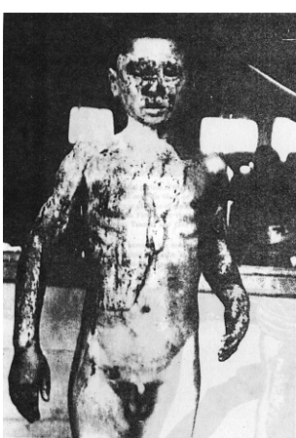**Document 10: Photographs of victims from Hiroshima**

1. 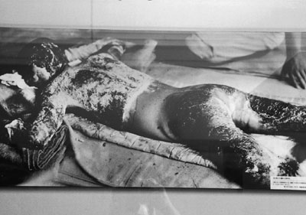 How did the bomb affect these residents of Hiroshima?
2. What is your reaction to seeing these pictures?
3. Right decision or wrong decision to use the bomb? Right Wrong

|  |  |  |
| --- | --- | --- |
| **Document** | **Right or wrong decision?** | **What does it say?** |
| #1 | Right | -need to show how strong the U.S. is  -will save American lives and end the war quickly |
| #2 |  |  |
| #3 |  |  |
| #4 |  |  |
| #5 |  |  |
| #6 |  |  |
| #7 |  |  |
| #8 |  |  |
| #9 |  |  |
| #10 |  |  |

**Dropping the Bomb-Analytical Essay Graphic Organizer**

**\*\*\*YOU MAY USE THIS ON YOUR TEST ESSAY\*\*\*\***

|  |  |
| --- | --- |
| Introduction Paragraph | |
| Background (how did the U.S. make Japan surrender?) |  |
|  |
|  |
| Thesis (did the U.S. make the right or wrong decision?) |  |
|  |
|  |
|  |  |

|  |  |
| --- | --- |
| Body Paragraph 1 (right decision) | |
| Topic Sentence: | _________________________________________________________________ |
| Specific evidence **and** which document each piece of information comes from (Doc. X) | ________________________________________________________________________  ________________________________________________________________________  ________________________________________________________________________  ________________________________________________________________________  ________________________________________________________________________  ________________________________________________________________________  ­________________________________________________________________________  ­________________________________________________________________________  ________________________________________________________________________ |
|  |  |
| Body Paragraph 2 (wrong decision) | |
| Topic Sentence: | _________________________________________________________________ |
| Specific evidence **and** which document each piece of information comes from (Doc. X) | ________________________________________________________________________  ________________________________________________________________________  ________________________________________________________________________  ________________________________________________________________________  ________________________________________________________________________  ________________________________________________________________________  ________________________________________________________________________  ________________________________________________________________________  ________________________________________________________________________  ________________________________________________________________________ |
|  |  |
| Conclusion Paragraph | |
| After considering all of the evidence, why should the reader agree with you? Why did you choose your argument? | _________________________________________________________________ |
|  |
|  |
|  |
| ________________________________________________________________________  ________________________________________________________________________  ________________________________________________________________________ |
| ________________________________________________________________________ |