Name: _____________________ Period: ___
DBQ: American Imperialism

Writing Prompt
Using the documents as evidence, you will answer this question in a 5 paragraph essay: What role did imperialism play in the shaping of American foreign policy in the late 19th and early 20th centuries?

Background Information
1. Write down everything you know about imperialism

2. What is foreign policy?

3. What can shape foreign policy?

4. What other questions would you need answered before you could write this DBQ?

5. Other notes

THE DBQ!
Directions
Now it’s time to analyze the primary and secondary sources. For each document:
- Take note the SOURCE at the end of each document.
- Read and annotate each document.
- Answer the guiding questions.

DOCUMENT A
"I walked the floor of the White House night after night until midnight; and I am not ashamed to tell you, gentlemen, that I went down on my knees and prayed Almighty God for light and guidance more than one night. And one night late it came to me this way...(1) that we could not give them back to Spain -- that would be cowardly and dishonorable; (2) that we could not turn them over to France or Germany -- our commercial rivals in the Orient -- that would be bad business and discreditable; (3) that we could not leave them to themselves -- they were unfit for self government -- and they would soon have anarchy and misrule worse than Spain's was; and (4) that there was nothing left for us to do but take them all, and to educate the Filipinos, and uplift and civilize them, and by God's grace do the very best we could by them..."
SOURCE: William McKinley, speech to a Methodist Church group, November 1899.

1. To which country is President McKinley referring? How do you know?

2. According to this document, what kind of role did imperialism play in US foreign policy?

DOCUMENT B
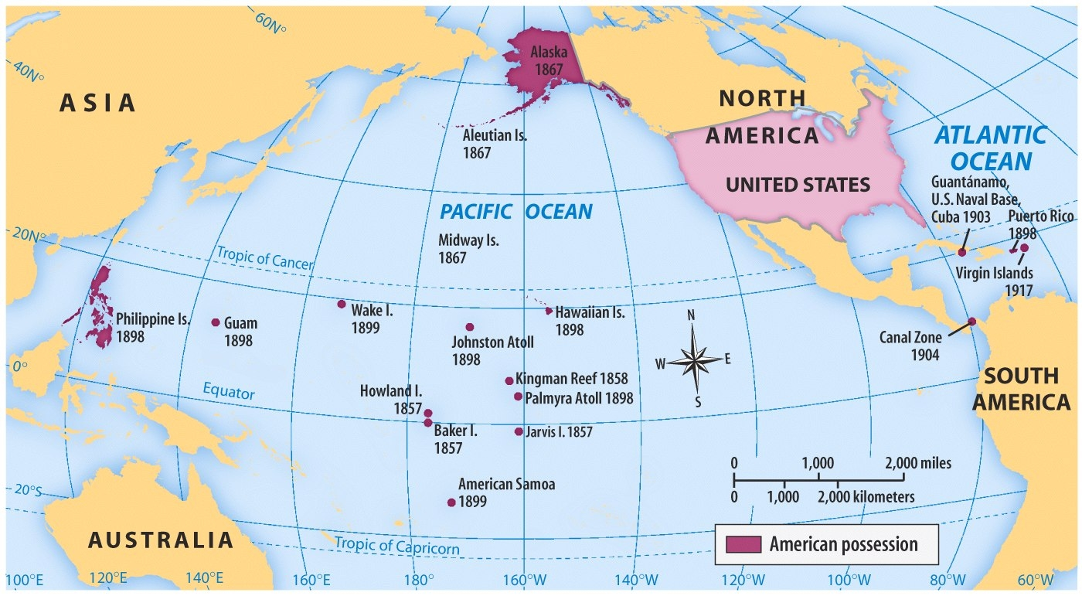
SOURCE: Prentice Hall, America: Pathways to the Present, 2003
- What is this map showing?

- According to this document, what kind of role did imperialism play in US foreign policy?
DOCUMENT C
"The American Flag flies high over a theater in Havana, Cuba"
SOURCE: American Horcoscopic Co. 1890s
- Why did the American flag fly over Cuba?

2. According to this document, what kind of role did imperialism play in US foreign policy?

DOCUMENT D
"Article I: The Government of Cuba shall never enter into any treaty or other compact with any foreign powers which will impair or tend to impair the independence of Cuba, nor in any manner authorize or permit any foreign power or powers to obtain by colonization or for military or naval purposes, or otherwise, lodgment in or control over any portion of said island. ...

"Article III: The Government of Cuba consents that the United States may exercise the right to intervene for the preservation of Cuban independence, the maintenance of a government adequate for the protection of life, property, and individual liberty, and for discharging the obligations with respect to Cuba imposed by the Treaty of Paris on the United States, now to be assumed and undertaken by the Government of Cuba...

"Article VII: To enable the United States to maintain the independence of Cuba, and to protect the people thereof, as well as for its own defense, the Government of Cuba will sell or lease to the Unites Sates lands necessary for coaling or naval stations, at certain specified points, to be agreed upon with the President of the United States."
SOURCE: The Platt Amendment, 1903.

- What was the purpose of the Platt Amendment?

2. According to this document, what kind of role did imperialism play in US foreign policy?

DOCUMENT E
"...We earnestly condemn the policies of the present National Administration in the Philippines...We denounce the slaughter of the Filipinos as a needless horror. We protest against the extension of American Sovereignty by Spanish methods.

"We demand the immediate cessation of the war against liberty, begun by Spain and continues by us. We urge that congress be promptly convened to announce to the Filipinos our purpose to concede to them the independence for which they have so long fought and which is right of theirs.

"The United States have always protested against the doctrine of international law which permits the subjugation of the weak by the strong. A self-governing state cannot accept sovereignty over an unwilling people. The United States cannot act upon the ancient heresy that might makes right...When the white man governs himself, that is self-government, but when he governs himself and also governs another man, that is more than self-government -- that is despotism."
SOURCE: The Anti-Imperialist League, 1899.

- Summarize this passage.

2. According to this document, what kind of role did imperialism play in US foreign policy?

DOCUMENT F
"The rule of liberty that all just government [gets] its authority from the [permission] of the governed, applies only to those who are capable of self-government. ... Would not the people of the Philippines prefer the just, humane, civilizing government of this Republic to the savage, bloody rule of pillage and extortion from which we have rescued them? ...

"...do we owe no duty to the world? Shall we turn these people back to the reeking hands from which we have taken them? Shall we abandon them, with Germany, England, Japan, hungering for them? Shall we save them from these nations, to give them a self-rule of tragedy?...

"...[President Thomas] Jefferson, who dreamed of Cuba as an American state; Jefferson, the first Imperialist of the Republic -- Jefferson acquired that imperial territory which swept from the Mississippi to the mountains, from Texas to the British possessions, and the march of the flag began!...
SOURCE: "The March of the Flag", Albert J. Beveridge 1898.
- According to this document, what is America’s duty to other countries like the Philippines and Cuba? Why does America have this duty?

2. According to this document, what kind of role did imperialism play in US foreign policy?

DOCUMENT G
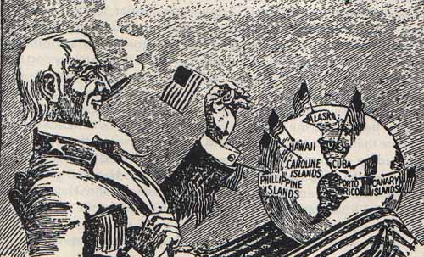
"Uncle Sam Wished to Add Another Star to His Flag"
SOURCE: Denver Rocky Mountain News, 1900

- What is the main idea of this cartoon?

- According to this document, what kind of role did imperialism play in US foreign policy?

ESSAY OUTLINE
Writing Prompt: What role did imperialism play in the shaping of American foreign policy in the late 19th and early 20th centuries?
Introduction Paragraph
Thesis:

Background Information:

Body Paragraphs
Main Idea  Evidence  Analysis  Link/Conclusion | Main Idea  Evidence  Analysis  Link/Conclusion
Main Idea  Evidence  Analysis  Link/Conclusion | Main Idea  Evidence  Analysis  Link/Conclusion

Conclusion: Restate Thesis/Evidence and explain topic’s importance on today’s society.

