# Name: _____________________________________________________________________

# "Does Jazz Put the Sin in Syncopation?"

**Written by Anne Shaw Faulkner**

**Head of the Music Department of the General Federation of Women's Clubs.**

**Published in** **Ladies Home Journal, August 1921, pp. 16-34.**

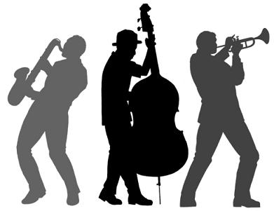We have all been taught to believe that "music soothes…," but we have never stopped to consider that an entirely different type of music might invoke savage instincts. We have been content to accept all kinds of music, and to admit music in all its phases into our homes, simply because it was music. It is true that frequently father and mother have preferred some old favorite song or dance, to the last "best seller" which has found its way into the home circle; but, after all, young people must be entertained and amused, and even if the old-fashioned parents did not enjoy the dance music of the day, they felt it could really do no harm, because it was music.

Therefore, it is somewhat of a rude awakening for many of these parents to find that America is facing a most serious situation regarding its popular music. Welfare workers tell us that never in the history of our land have there been such immoral conditions among our young people, and in the surveys made by many organizations regarding these conditions, the blame is laid on jazz music and its evil influence on the young people of to-day. Never before have such outrageous dances been permitted in private as well as public ballrooms, and never has there been used for the accompaniment of the dance such a strange combination of tone and rhythm as that produced by the dance orchestras of to-day.

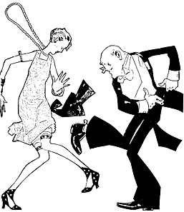Certainly, if this music is in any way responsible for the condition and for the immoral acts which can be traced to the influence of these dances, then it is high time that the question should be raised: "Can music ever be an influence for evil?" …

That jazz is an influence for evil is also felt by a number of the biggest country clubs, which have forbidden the jazz orchestras-- evils which have also been eliminated from many [local] dance halls.

Still another proof that jazz is recognized as producing an evil effect is the fact that in almost every big industry where music has been instituted it has been found necessary to discontinue jazz because of its demoralizing effect upon the workers. This was noticed in an unsteadiness and lack of evenness in the workmanship of the product after a period when the workmen had indulged in jazz music. …

Jazz originally was the accompaniment of the voodoo dancer, stimulating the half-crazed barbarian to the vilest deeds. The weird chant, accompanied by the syncopated rhythm of the voodoo invokers, has also been employed by other barbaric people to stimulate brutality and sensuality. That it has a demoralizing effect upon the human brain has been demonstrated by many scientists. … Jazz disorganizes all regular laws and order; it stimulates to extreme deeds, to a breaking away from all rules and conventions; it is harmful and dangerous, and its influence is wholly bad. … Such music has become an influence for evil.

**“Does Jazz Put the Sin in Syncopation” Questions**

**Directions:** Answer the following questions about the 1921 *Ladies’ Home Journal*. (8 pts)

1. **What influence did the author of this article say that jazz music has on young people? (1 pts)**

________________________________________________________________________________________________________________________________________________________________________________________________________________________________________________________________________________________________________________________________________________

1. **What are two examples of “evidence” that the author provides in her condemnation of jazz music? (2 pts)**

________________________________________________________________________________________________________________________________________________________________________________________________________________________________________________________________________________________________________________________________________________

1. **Where does the author say that jazz originally came from? Why do you think she mentioned this? (3 pts)**

________________________________________________________________________________________________________________________________________________________________________________________________________________________________________________________________________________________________________________________________________________

1. **While today, this article may seem amusing in reference to jazz music, how does this article relate to modern American society? (2 pts)**

____________________________________________________________________________________

____________________________________________________________________________________

**Name: _______________________________________________________________**

**Let America Be America Again**

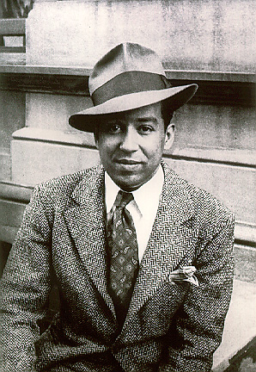**by Langston Hughes**

Let America be America again.

Let it be the dream it used to be.

Let it be the pioneer on the plain

Seeking a home where he himself is free.

(America never was America to me.)

Let America be the dream the dreamers dreamed -

Let it be that great strong land of love

Where never kings connive nor tyrants scheme

That any man be crushed by one above.

(It never was America to me.)

O, let my land be a land where Liberty

Is crowned with no false patriotic wreath,

But opportunity is real, and life is free,

Equality is in the air we breathe.

(There's never been equality for me,

Nor freedom in this "homeland of the free.")…

I am the poor white, fooled and pushed apart,

I am the Negro bearing slavery's scars.

I am the red man driven from the land,

I am the immigrant clutching the hope I seek -

And finding only the same old stupid plan

Of dog eat dog, of mighty crush the weak. …

The free?

Who said the free? Not me?...

For all the dreams we've dreamed

And all the songs we've sung

And all the hopes we've held

And all the flags we've hung,

The millions who have nothing for our pay--

Except the dream that's almost dead today.

O, let America be America again-

The land that never has been yet -

And yet must be - the land where every man is free.

The land that's mine - the poor man's, Indian's, Negro's, ME -

Who made America,

Whose sweat and blood, whose faith and pain,

Whose hand at the foundry, whose plow in the rain,

Must bring back our mighty dream again. …

**“Let America Be America Again” by Langston Hughes Questions (8 pts)**

1. What did Langston Hughes mean when he said that “America was never America to me?” (2 pts)

___________________________________________________________________________________________

___________________________________________________________________________________________

___________________________________________________________________________________________

___________________________________________________________________________________________

1. Who are the four groups of people that Hughes points out as being treated unfairly in America? (2 pts)

___________________________________________________________________________________________

___________________________________________________________________________________________

___________________________________________________________________________________________

___________________________________________________________________________________________

1. When the poem says that the “mighty crush the weak,” who is “the mighty” referring to? Who is “the weak” referring to? (2 pts)

___________________________________________________________________________________________

___________________________________________________________________________________________

___________________________________________________________________________________________

___________________________________________________________________________________________

1. In the last five lines of the poem, what point is Hughes trying to make? (2 pts)

___________________________________________________________________________________________

___________________________________________________________________________________________

___________________________________________________________________________________________

___________________________________________________________________________________________

[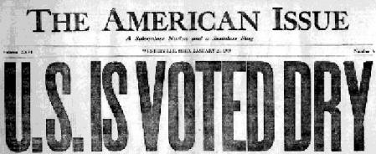](http://mrburdick.edublogs.org/files/2010/11/usdry-16046w5.jpg)

**Read these directions.**

***ATTN: Make sure that you save what you write in a word processor (Notepad, Microsoft Word, etc.) in order to back up your work, just in case your comment does not post. If you don’t and you lose your work, you will be required to type it again.***

**I**magine that the year is 2016 and the debate over making alcohol illegal has become a political hot topic once again. In the town in which you live, you have been assigned to join in on a town-wide discussion and debate on whether the prohibition of alcohol should once again happen or whether it should stay legalized.

You were assigned a position in class. Whether you agree with the position you were assigned or not does not matter – learning to debate the **OTHER** side of any issue is an important skill to have.

**Instructions:**

**1. Answer your assigned prompt below in full sentences with correct punctuation and grammar**. This response should be at least **200 words** and should have at least **two sources** that help validate your claims and strengthen your argument.

**2. You are required to respond AT LEAST two additional times to somebody else’s comments**. To respond to somebody: Acknowledge the person who you are talking to by first name and make it clear what point of theirs that you are refuting.

Personal insults and inappropriate comments will result in a grade of zero, a call home, and disciplinary action. Let’s keep it civil, folks.

**DEBATE VIEW #1: SUPPORT ANTI-ALCOHOL PROHIBITION LAWS**Explain reasons as to why alcohol **should** be banned. How will the problems associated with the banning of alcohol be addressed (example: illegal sales of alcohol, corruption, gangster empires, etc.)? Present a clear and detailed argument for full credit.

**DEBATE VIEW #2: END ANTI-ALCOHOL PROHIBITION LAWS**Explain reasons as to why alcohol **should not** be banned. Why is prohibition an infringement on the rights of Americans? What are some of the problems associated with the banning of alcohol? Present a clear and detailed argument for full credit.

**Don’t forget your two counter-arguments!**

|  |  |
| --- | --- |
| What was good about Prohibition?  1.  2.  3.  4.  5. | What was bad about Prohibition?  1.  2.  3.  4.  5. |

**Name: __________________________________________________________________**

**The Sacco-Vanzetti Case**

**U.S. History**

**The Accused**

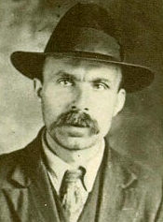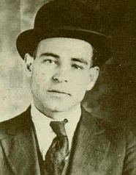**Nicola Sacco Bartolomeo Vanzetti**

**Born:** April 22, 1891 in Italy **Born:** June 11, 1888 in Italy

**Occupation:** Shoemaker **Occupation:** Fish monger

**FOUND GUILTY FOUND GUILTY**

**The Crime**

**When:** April 15, 1920, approximately 3:00 PM

**Where:** Slater & Morril Shoe Company – South Braintree, MA

Two men robbed a shoe company of their $15,776.51 payroll, shooting and killing the paymaster, Frederick Parmenter, and a security guard, Alessandro Berardelli. Three weeks later, two Italian immigrants named Nicola Sacco and Bartolomeo Vanzetti were arrested after going to a garage to pick up a car that police believed was used in the robberies.

In American courts, the accused are considered innocent until proven guilty, not guilty until proven innocent. Yet, due to the prejudice that many Americans at the time felt towards immigrants in part because of the tension created by World War I, many leapt to the conclusion that Sacco and Vanzetti were guilty even before the trial began. Both plead innocent to the charges of armed robbery and murder, but on July 14, 1921, they were both found guilty by a jury and sentenced to death. Many Americans applauded the verdict, feeling justice had been served. Many others, such as muckraker Upton Sinclair (who wrote *The Jungle*), led citizen-driven committees to investigate the fairness of the trial and the guilty verdict. Over the next six years, Sacco and Vanzetti’s lawyers filed appeal after appeal for a new trial, postponing their death sentence in an attempt to prove their innocence, but all requests were denied by Judge Webster Thayer, despite new and important evidence coming to light. On August 23, 1927, the two men – who still proclaimed they were innocent - were executed by electrocution.

**The Evidence**

-Sacco and Venzetti were members of an Italian-American anarchist *(one who opposes all forms of government)* group.

-Sacco owned a gun similar to the murder weapon and the bullets used in the murders matched those in Sacco’s gun.

-A handful of witnesses identified Sacco and Vanzetti as the culprits.

**Sacco and Vanzetti’s lawyers say:**

-They were unjustly convicted of crime they did not commit.

-They were victims of ethnic prejudice (Italian immigrants) and political prejudice (anarchists).

-There was improper conduct by judge who swayed jury with his prejudice and anti-immigrant and anti-anarchist talk.

-Judge Thayer asked to be put on this trial and refused five appeals for a re-trial.

-Sacco and Vanzetti each had alibis [or people who said the men were with them when the crime took place] who testified as to where they were when the robbery and murders took place.

-Judge pointed out that alibis were also immigrant anarchists.

**In their own words:**

**Sacco:** I never knew, never heard, even read in history anything so cruel as this Court.  After seven years prosecuting they still consider us guilty. I know the sentence will be between … the [poor] class and the rich class, and there will be always collision between one and the other. You [bully] the people … and kill them. … That is why I am here today on this bench, for having been of the [poor] class.  Well, you are the [bully]. You know it, Judge Thayer … Among that peoples and the comrades and the working class there is a big legion of intellectual people which have been with us for seven years, [begging you] to not commit the wicked sentence [of death], but still the Court goes ahead. As I said before, Judge Thayer, [you know] that I am never guilty, never - not yesterday, nor today, nor forever.

**Vanzetti:** Everybody that knows [me] knows very well that I did not need to go into the streets and kill a man or try to take money. I can live by [working with] my two hands and live well. Now, I should say that I am not only innocent of all these things, not only have I never committed a real crime in my life - though [I’ve committed] some sins but not crimes – [but I have] struggled all my life to eliminate crimes … [T]he Judge had either forgot or omitted to tell the jury that they should consider [us] innocent until found guilty in the court, or something of that sort. … We have proved that there could not have been another Judge on the face of the earth more prejudiced, more cruel and more hostile than you have been against us. We have proven that. Still they refuse the new trial. We know, and you know in your heart, that you have been against us from the very beginning, before you [even saw] us. Before you see us you already know that we were radical [anarchists], that we were underdogs, that we were the enemy of the institutions that you can believe in good faith in their goodness. We know that you have spoken yourself, and have spoke your hostility against us, and your despisement against us with friends of yours. I am suffering because I am [an anarchist] and indeed I am [an anarchist]; I have suffered because I am Italian, and indeed I am an Italian; I have suffered more for my family and for my beloved than for myself; but I am so convinced to be right that you can only kill me once but if you could execute me two times, and if I could be reborn two other times, I would live again to do what I have done already. I have finished. Thank you.

**Judge Webster Thayer was alleged to have said by witnesses:** “[We will get these] Bolshevik’s good and proper!”

**The Analysis**

1. **What are three reasons that Sacco and Vanzetti felt that they were not given a fair trial?**
2. ___________________________________________________________
3. ___________________________________________________________
4. ___________________________________________________________
5. **Many, included Upton Sinclair, argued that Judge Thayer’s prejudice affected his judgment in the courts. For what specific reasons did people accuse Judge Thayer of prejudice?**

**________________________________________________________________________________________**

**________________________________________________________________________________________**

1. **When Sacco spoke, he said that the trial was a fight between what two things?**

**________________________________________________________________________________________**

1. **Vanzetti tells the court that Judge Thayer forgot to tell the jury that they were “innocent until proven guilty.” What does “innocent until proven guilty” mean? Why is this important in the court of law?**

**________________________________________________________________________________________**