*Should the United States Enter World War I?*

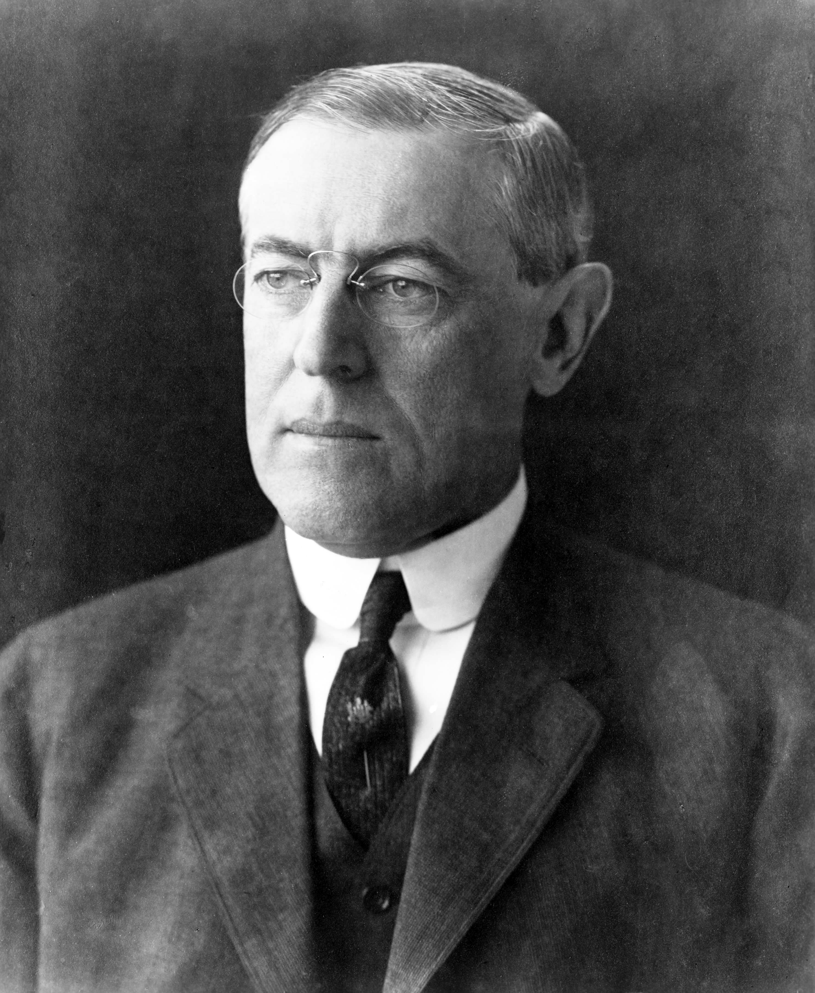

**Historical Context:**

On April 2,1917 found President Wilson standing before a joint session of Congress asking that war be declared against Germany.

**Major Question: Should the United States enter World War I?**

*Making Generalizations:* Below are groups of statements made before, during, and after America’s involvement in World War I. Read the statements in each group and identify the key reasons why the United States entered World War I. Then write a summary of the major arguments presented in each statement.

|  |
| --- |
| 1. On the third of February last I officially laid before you the extraordinary announcement of the Imperial German Government that on and after the first day of February it [would] use its submarines to sink every vessel that sought to approach…Great Britain…or the western coasts of Europe…The new policy has swept every restriction aside…The present German submarine warfare against commerce is warfare against all mankind. President Woodrow Wilson's War Message (April 1917) |
|  |
| **2.** “Our object...is to vindicate the principles of peace and justice in the life of the world as against selfish and autocratic power.... We are glad...to fight...for the ultimate peace of the world and for the liberation of its peoples, the German peoples included: for the right of nations great and small and the privilege of men everywhere to choose their way of life and of obedience. The world must be made safe for democracy....” —President Woodrow Wilson's War Message (April 1917) |
|  |
| **3.** ”We didn't win a thing we set out for in the last war (World War I). We merely succeeded, with tremendous loss of life, to make secure the loans of private bankers to the Allies.” —Senator Gerald Nye of North Dakota, Chairman of the Senate Munitions Committee (circa 1936) |
|  |
| **4.** …through the instrumentality of others who have not only made millions out of the war in the manufacture of munitions, etc., and who would expect to make millions more if our country can be drawn into the catastrophe… —Senator George W. Norris in Opposition to President Woodrow Wilson's War Message (April 4, 1917) |
|  |
| **5.** “…We have loaned many hundreds of millions of dollars to the Allies in this controversy…there is no doubt in my mind but the enormous amount of money loaned to the Allies in this country has been instrumental in bringing about a public sentiment in favor of our country taking a course that would make every bond worth a hundred cents on the dollar and making the payment of every debt certain and sure.” —Senator George W. Norris in Opposition to President Woodrow Wilson's War Message (April 4, 1917)  By 1917, American loans to the Allies had soared to $2.25 billion; loans to Germany stood at a paltry $27 million.  —The Gilder Lehrman Institute of American History |
|  |
| **6.** “That which has driven the masses of Europe into the trenches and to the battlefields is not their inner longing for war; it must be traced to the cutthroat competition for military equipment, for more efficient armies, for larger warships, for more powerful cannon. You cannot build up a standing army and then throw it back into a box like tin soldiers.” —Emma Goldman, from "Preparedness: The Road to Universal Slaughter" |
|  |
| **7.** “…a large number of the great newspapers and news agencies of the country have been controlled and enlisted in the greatest propaganda that the world has ever known to manufacture sentiment in favor of war.” —Senator George W. Norris in Opposition to President Woodrow Wilson's War Message (April 4, 1917) |
|  |
| **8.**  in**.** In view of recent acts of the German authorities in violation of American rights on the high seas which culminated the torpedoing and sinking of the British steamship Lusitania on May 7, 1915, by which over 100 American citizens lost their lives, it is clearly wise and desirable that the government of the United States and the Imperial German government should come to a clear and full understanding as to the grave situation which has resulted.  The sinking of the British passenger steamer Falaba by a German submarine on March 28, through which Leon C. Thrasher, an American citizen, was drowned; the attack on April 28 on the American vessel Cushing by a German aeroplane; the torpedoing on May 1 of the American vessel Gulflight by a German submarine, as a result of which two or more American citizens met their death; and, finally, the torpedoing and sinking of the steamship Lusitania constitute a series of events which the government of the United States has observed with growing concern, distress, and amazement |
|  |
| **9.** *January 1917, British intelligence officers intercepted this message being sent form the German Foreign Minister to the government of Mexico.*  In the event (that the United States in drawn into war) we make Mexico a proposal of alliance on the following basis: make war together, make peace together, generous financial support and an understanding on our part that Mexico is to reconquer the lost territory in Texas, New Mexico, and Arizona. |
|  |

**CONCLUSION**: Based upon your own knowledge of the topic and on the evidence found in the documents, **formulate a thesis statement that directly answers the question:**

*Should the United States Enter World War I?*

Your thesis statement must include at least 3 main points