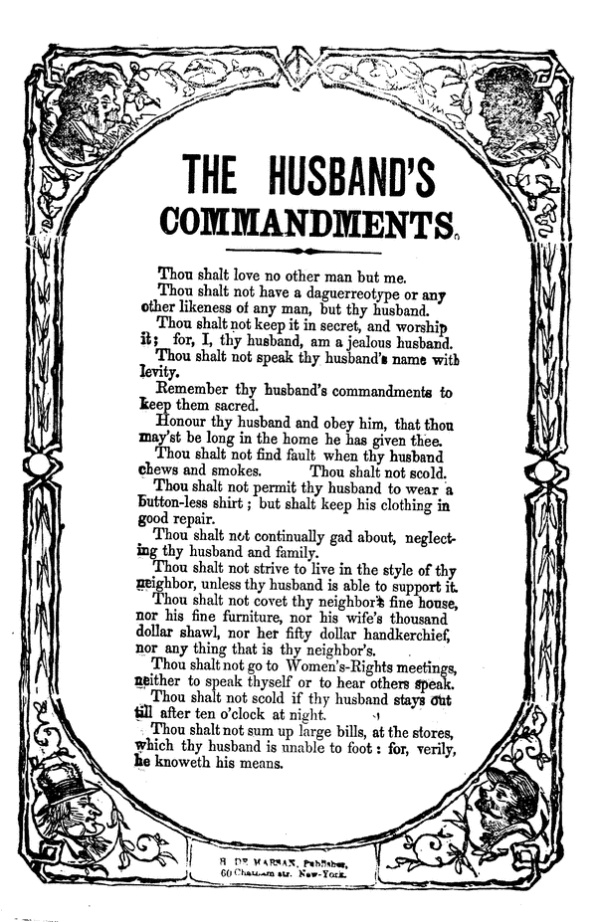http://memory.loc.gov/cgi-bin/ampage?collId=amss&fileName=sb2/sb20184a/amsspage.db&recNum=0
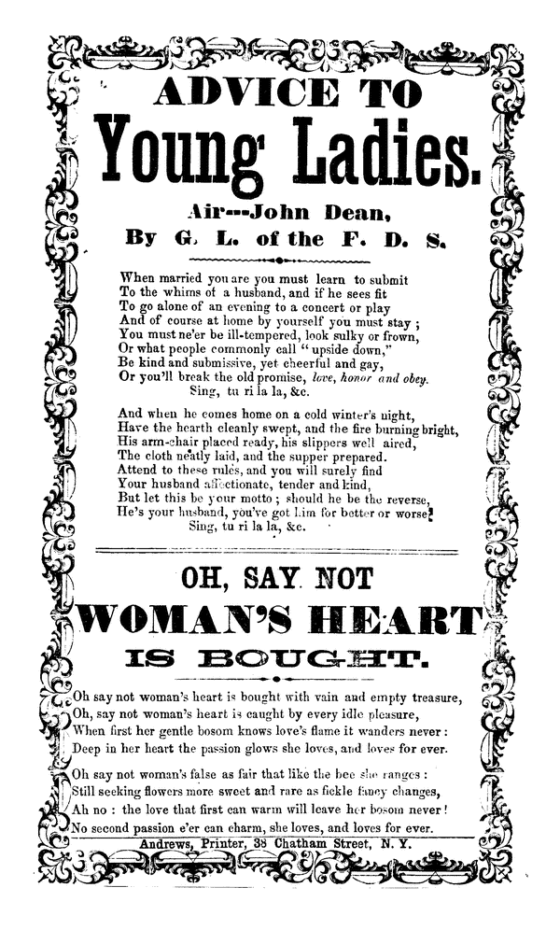
EXCERPT FROM REV. JOHN TODD 1
“WOMEN’S RIGHTS”
EQUALITY OF THE SEXES.
On this question I shall waste no words. Nobody pretends that the sexes are equal in weight, in height, or in bodily strength. The bodies of the two sexes seem to have been planned for different ends. As to the mind, I have no difficulty in admitting that the mind of woman is equal to ours,-nay, if you please, superior. It is quicker, more flexible, more elastic. I certainly have never seen boys learn languages or mathematics, up to a certain point, as fast or as easy as some girls. Woman's intuitions also are far better than ours. She reads character quicker, comes to conclusions quicker, and if I must make a decision on the moment, I had much rather have the woman's decision than man's. She has intuitions given her for her own protection which we have not. She has a delicacy of taste to which we can lay no claim. "Why, then," my lady reader will say, " why can't we be independent of man? " for this is the gist of the whole subject. I reply, you can't, for two reasons; first, God never designed you should, and secondly, your own deep instincts are in the way. God never designed that woman should occupy the same sphere as man, because he has given her a physical organization so refined and delicate that it can never bear the strain which comes upon the rougher, coarser nature of man. He has hedged her in by laws which no desires or efforts can alter. We, sons of dust, move slower; we creep, where you bound to the head of the stairs at a single leap. And now bear with me, and keep good-natured, while I show you, what you, dear ladies, cannot do, and God don't ask you to do.
* 1. You cannot invent. There are all manner of inventions in our age, steam, railroads, telegraphing, machinery of all kinds, often five hundred and fifty weekly applications for patents at the Patent Office, but among them all no female applicants. You have sewing machines almost numberless, knitting machines, washing, ironing, and churning machines-but I never heard of one that was the emanation of the female mind. Did you? Why sew, or wash, or card off your fingers, rather than to invent, if this was your gift? The old spinning-wheel and the old carding apparatus have gone by, out not by woman's invention. I suppose this power was denied you, lest it should take you out of your most important sphere-as I shall show.
* 2. You cannot compete with men in a long course of mental labor. Your delicate organization never has and never can bear the study by which you can become Newtons, La Places, or Bowditches in mathematics or astronomy. The world never has seen, and never expects to see, woman excelling in architecture. Neither in ancient or modern times has she one monument of this kind, showing mastership. You do not find them in ancient Corinth, old Athens, great Rome, or in any city of the old or new world.

EXCERPT FROM REV. JOHN TODD 2
“WOMEN’S RIGHTS”
WOMAN'S EDUCATION PART 1
I lately took up a religious paper, in which no less than six "Female Colleges" were advertised and puffed. And we are getting our legislatures to charter new "Female Colleges," and we are boasting how we are about to introduce all the studies and the curriculum of the colleges for men, and we are to put our daughters through them, and educate just as we do men.
The thing can never be done. For forty years I have been connected with female seminaries, and have carefully watched their training and results. I say deliberately, that the female has mind enough, talent enough, to go through a complete college course, but her physical organization, as a general thing, will never admit of it. I think the great danger of our day is forcing the intellect of woman beyond what her physical organization will possibly bear.
We want to put our daughters at school at six, and have their education completed at eighteen. A girl would feel mortified not to be through schooling by the time she reaches that age. In these years the poor things has her brain crowded with history, grammar, arithmetic, geography, natural history, chemistry, physiology, botany, astronomy, rhetoric, natural and moral philosophy, metaphysics, French, often German, Latin, perhaps Greek, reading spelling, committing poetry, writing compositions, drawing, painting, c., ad infinitum. Then out of school hours, from three to six hours of severe toil at the piano. She must be on the strain all the school hours, study in the evening till her eyes ache, her brain whirls, her spine yields and gives way, and she comes through the process of education enervated, feeble, without courage or vigor, elasticity or strength.
After a single summer's exhausting study, let sickness strike such a school, and they sink and die most fearfully. Do those who are so strenuous to educate ladies as long and as severely as men must be educated for their sphere, know what mortality awaits so many after they are educated? I wish they would examine this point. "Languid and nervous, easily dispirited, instead of feeling within themselves the freshness and buoyancy of youth, what wonder that they draw back, appalled, from their new responsibilities" at marriage. So says a lady writing to me from Minnesota.

"Are Women People? A Book of Rhymes for Suffrage Times"
Introduction
Father, what is a Legislature?
A representative body elected by the people of the state.
Are women people?
No, my son, criminals, lunatics and women are nor people.
Do legislators legislate for nothing?
Oh, no; they are paid a salary.
By whom?
By the people.
Are women people?
Of course, my son, just as much as men are.
Our Idea of Nothing at All
("I am opposed to woman suffrage, but I am not opposed to woman."- Anti-suffrage speech of Mr. Webb of North Carolina.)
O WOMEN, have you heard the news
Of charity and grace?
Look, look, how joy and gratitude
Are beaming in my face!
For Mr. Webb is not opposed
To woman in her place!
O Mr. Webb, how kind you are
To let us live at all,
To let us light the kitchen range
And tidy up the hall;
To tolerate the female sex
In spite of Adam's fall.
O girls, suppose that Mr. Webb
Should alter his decree!
Suppose he were opposed to us-
Opposed to you and me.
What would be left for us to do-
Except to cease to be?

On Not Believing all You Hear
("Women are angels, they are jewels, they are queens and princesses of our hearts."- Anti-suffrage speech of Mr. Carter of Oklahoma.)
" Angel, or jewel, or princess, or queen, Tell me immediately, where have you been?"
"I've been to ask all my slaves so devoted Why they against my enfranchisement voted."
"Angel and princess, that action was wrong. Back to the kitchen, where angels belong."
Our Own Twelve Anti-suffragist Reasons
* 1. Because no woman will leave her domestic duties to vote.
* 2. Because no woman who may vote will attend to her domestic duties.
* 3. Because it will make dissension between husband and wife.
* 4. Because every woman will vote as her husband tells her to.
* 5. Because bad women will corrupt politics.
* 6. Because bad politics will corrupt women.
* 7. Because women have no power of organization.
* 8. Because women will form a solid party and outvote men.
* 9. Because men and women are so different that they must stick to different duties.
* 10. Because men and women are so much alike that men, with one vote each, can represent their own views and ours too.
* 11. Because women cannot use force.
* 12. Because the militants did use force.

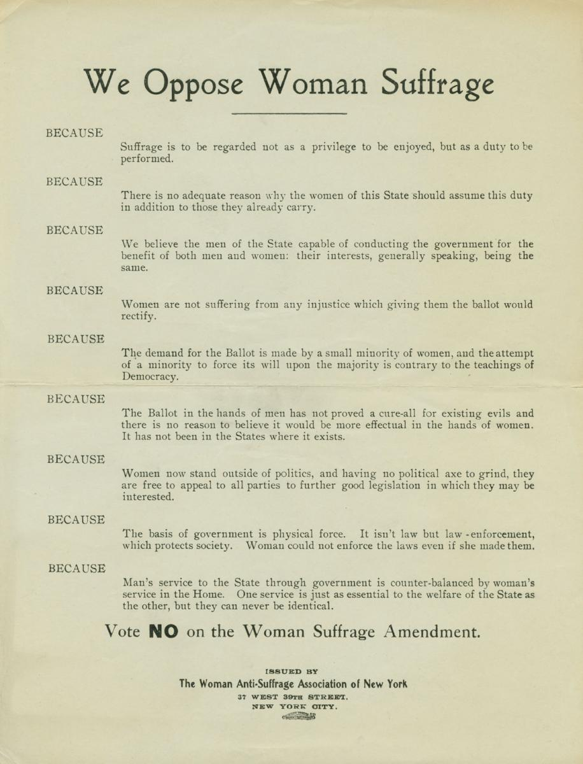
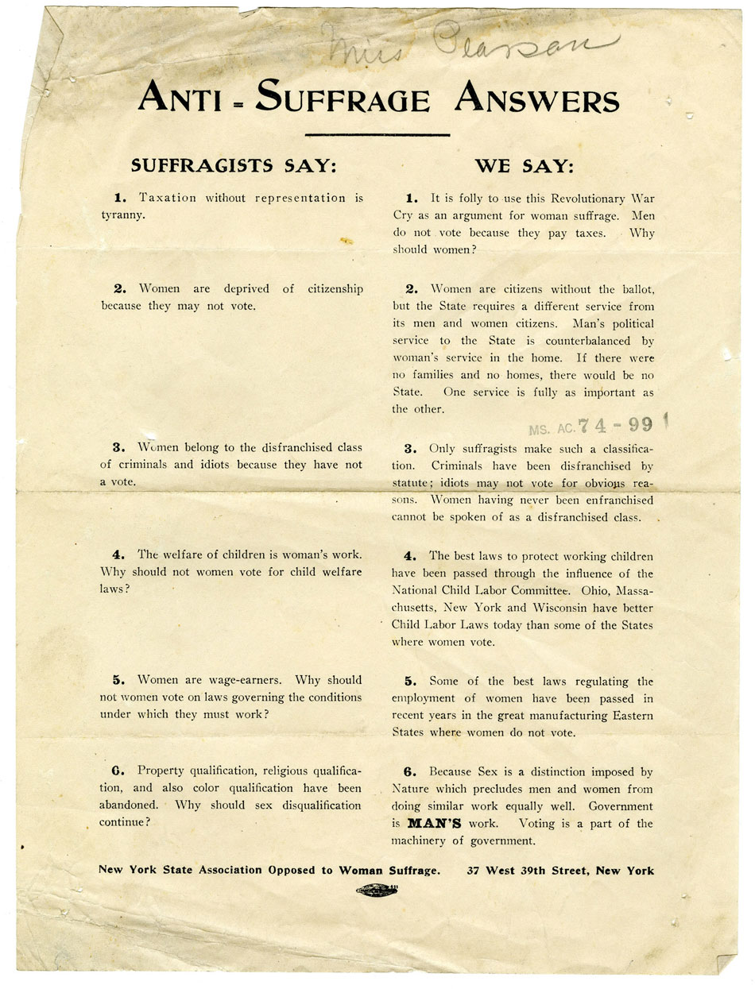
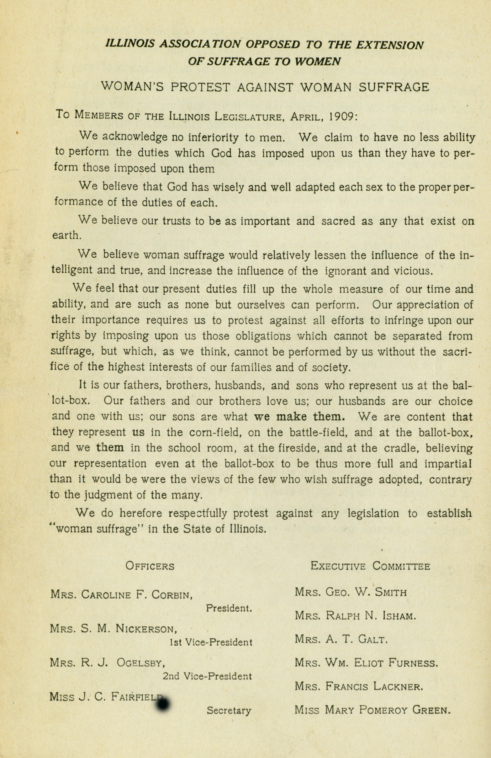
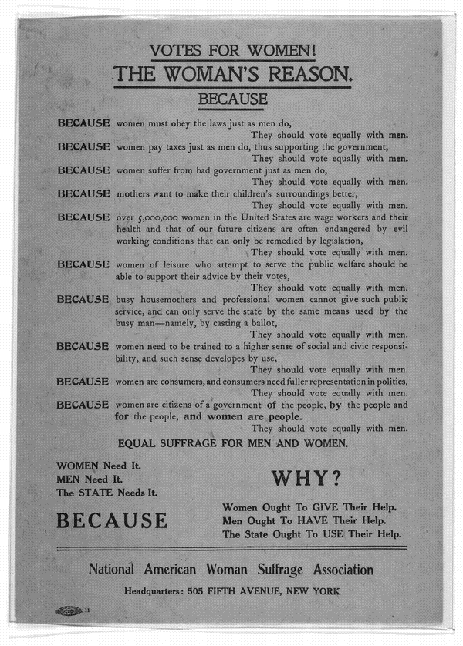
DON’T FAIL TO READ THIS.

At the election to be held November 7th, an amendment to the Constitution conferring the right of suffrage upon women, will be voted on. T
History does not show a single instance in which woman suffrage has improved society or government; on the contrary, the municipal affairs of towns in Kansas where women have voted and were elected to office, are in worse shape than ever before.
After a trial of twenty-four years in Wyoming, it is conceded that it has failed to bring about reforms of any kind, but has resulted in engaging women in the very laudable work of packing caucuses, primaries and conventions-in lowering women to the depths of all that low politics imply.
Utah furnishes us with the most striking example of what women cannot do. There the right to vote was early conferred upon women by the territorial assembly and if there ever was a magnificent opportunity offered women to assert herself at the ballot--it was there. But instead of abolishing polygamy or lending her influence in that direction, she became a powerful agency in upholding that evil and Congress, after repeated efforts to crush it, found that it could only be done by abolishing Woman Suffrage. Polygamy is now a thing of the past.
The great cry of our female agitators, “Taxation without representation,” may be a very good argument if rightly applied, but as the percentage of women paying taxes is much smaller than that of men, and as there are 100 women who pay no taxes where there is one woman who does, we utterly fail to see how equal suffrage will increase the representation of tax paying women. In fact the result will be exactly the reverse. Most of these women have no children and therefore few family ties to keep them at home. In the absence of woman’s proper occupations, they run the country over, reviling everything in general and men in particular, and such women as these are the ones who would rule under a regime of woman suffrage.
Young man, if you don’t want a female lawyer, doctor or politician for a wife, but would prefer a woman who will be a good companion, home maker, wife and mother, than vote and induce all your friends to vote against EQUAL SUFFRAGE.
This is a fight for our homes, for our families and for our personal liberties. We appeal to all fair minded voters to consider that should this amendment be adopted, only a few notoriety seeking women will be benefitted, while a great majority of citizens will be injured. The already weakened credit of our State will sink lower, for capital will not invest a dollar in our commonwealth, if a new element is thrust forward to make or unmake laws which would affect its security.

Do not depend upon others to cast their votes against this innocent looking but dangerous experiment, but see that your vote is cast against it. After reading this circular, please hand it to some friend. We want every voter to be made aware that this measure will come up, and we hope that every liberal minded man will oppose same by placing his X against the line
DO WOMEN WANT THE VOTE?
Suffrage is not a natural right. It is a question to be determined by the community solely by a consideration of its effect upon the public welfare. The majority of the women do not want to assume the burden of government. A very small minority of women demand the ballot. It is unjust to force new duties upon a large body of women who are indifferent or opposed to woman suffrage.
Voting is only a small part of government. If the duty of voting is laid upon women, the duty will also be laid upon them of taking an active part in the preliminaries necessary to voting, and in the consequences which result from voting. They must take part in political discussions and share in political campaigns, and see that the laws which they help to enact are enforced upon those that refuse to obey the laws.
Would it not impose Great Hardship on Many Women?
Equality in character does not imply similarity in function; the duties and life of men and women are different in the State, as in the home. Women have many physical limitations which do not exist for men, and already, as a rule their strength is over-taxed. The energies of women are engrossed by their present duties and interests, from which men cannot relieve them, and it is better for the community that they devote their energies to the better performance of their present work, than to divert them to new fields of activity. The ballot is not essential for the performance of woman's present duties.
Are not the Interests of Women Safe in the Hands of Men?
Quite as safe as in those of other women!
The woman suffragists always imply that men legislate only for their own interests. But in America men cannot be accused of indifference to the wishes and happiness of women. They would make any reasonable amendments in the laws affecting the welfare of women, if urged with half the force now brought to bear in favor of suffrage. Moreover, in general the interests of men and women are very much the same. Both desire good schools, good roads, good drainage, and good government. The prosperity of the town and of the State benefits both alike. Only in the common division of labor, certain duties are apportioned to each, according to their special conditions of strength and organization. These differences are not of human origin, and therefore cannot be changed by any so-called "reform."
Political equality will deprive woman of special privileges hitherto accorded to her by law.
Is the Ballot Essential to Woman's Public Usefulness?
Woman Suffrage would force woman into the political arena. This would impair her usefulness which she exercises to-day as a disinterested, non-partisan worker for the public good. She would duplicate man's work and lose her special value if she went into party politics.

Behind law there must always be force to make it effective. Women, by the limitations of their sex, are unfitted for the stern work of enforcing law. It would be ill for any State where legislation was shaped by women over the heads of a majority of men. Under such conditions you would soon have, not government, but chaos.
