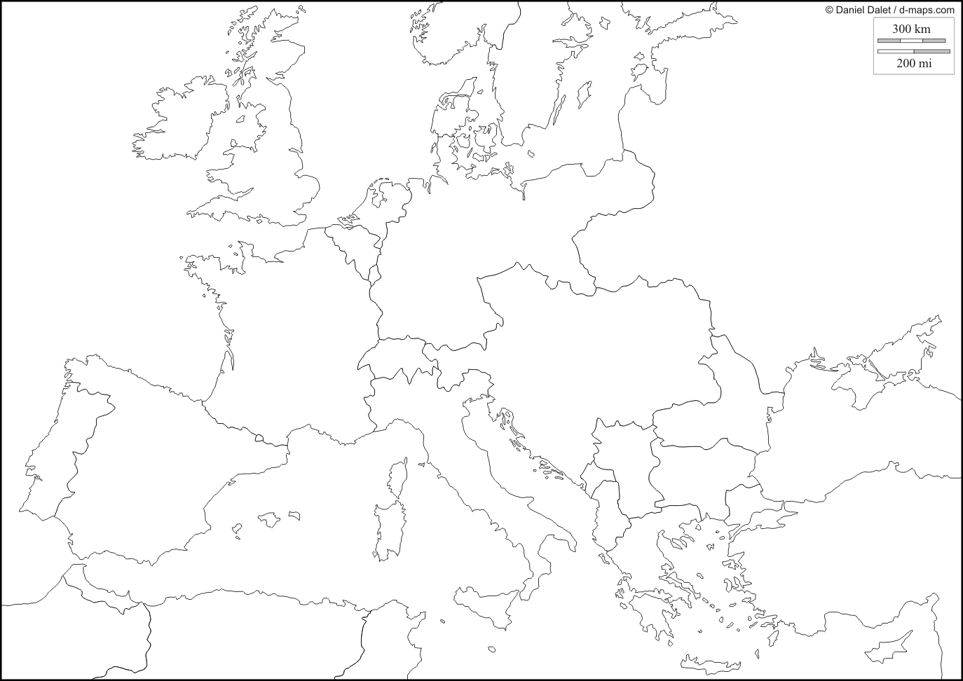

WWI Map

1. Draw a gun in Bosnia, the location where Gavrilo Princip assassinated Franz Ferdinand (the spark to World War One).
2. Label & shade the Central Powers in WWI: Germany, Austria-Hungary, Ottoman Empire, Bulgaria
3. Label and shade (with a different color) the Allied/Entente Powers in WWI: France, Russia, United Kingdom, Belgium, Serbia, Portugal, Greece, Albania, Montenegro *(United States, South Africa, Australia, Canada, India, New Zealand, Japan, Monaco, Nepal not pictured)*
4. Add to the Allied/Entente Powers: Italy and Romania, who agreed to join the allies in exchange for land spoils after the war.
5. Label the “Western Front” on the map with a thick dashed line, (include stick figure soldiers on either side).
6. Label the Eastern Front on the map (include stick figure soldiers on either side).
7. Label and place German “U-Boats” in the North Sea and around the United Kingdom (using small, shaded ovals).
8. Place a star on the 1916 Battle of the Somme in France (the largest battle of World War One).
9. Cross out Russia, and write “1917 Communist Revolution” next to it, indicating that Russia had dropped out of the war.
10. Central Powers Surrender in 1918! (Write the year of surrender on Germany)