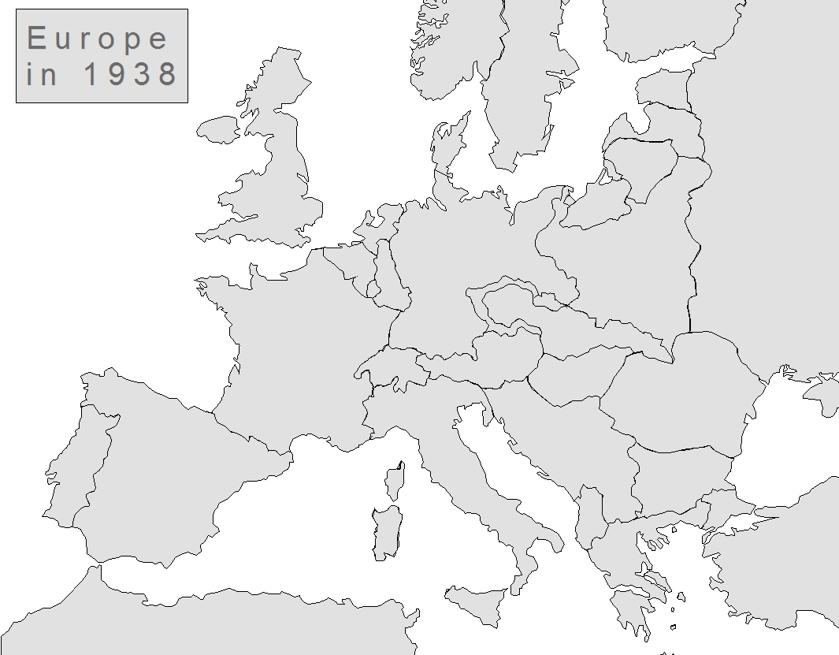

- Label: Germany, USSR, UK, France, Poland, Spain, Portugal, Italy, Austria, Yugoslavia, Romania, Norway, Sweden, Estonia, Latvia, Lithuania, Ireland, Czechoslovakia, Hungary, Bulgaria, Greece, Sicily, Switzerland, Belgium and the SUDENTENLAND.

- Label and color: Axis Powers and the land taken by the Axis, Allied Powers, and Neutral Countries

- Attach the names of the following leaders and their countries: Hitler, Stalin, Mussolini, Churchill, De Gaulle

- Label and color the English Channel.

- Put a star in the country that Hitler invaded that officially started WWII

- Put a fence around Great Britain to show that they were the strongest American ally. They were heavily bombed by Hitler but never invaded by land.

***Know All European Battle Locations***

